**Ethereal – MYTH**

**MYTH description**

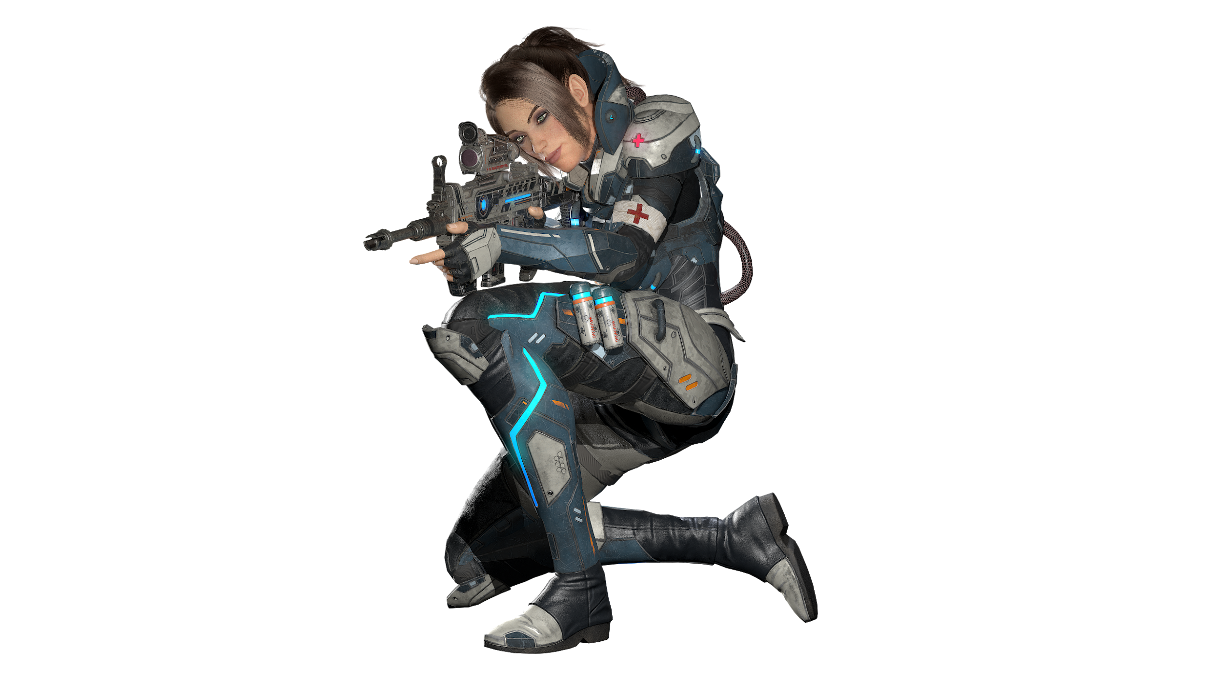

|  |  |
| --- | --- |
| **Name** | Dr. Grace |
| **Title** | The Renegade |
| **Realm** | Ovagon |
| **Region** | District 6 |
| **Class** | Cleric |
| **Type** | Ranged Physical |
| **Release Date** | Coming Soon |

Doctor Grace is a highly intelligent and proficient medical professional that specializes in combat medicine. A prodigy in her own, she possesses a photographic memory and the ability to analyze and quickly extrapolate information. When she was young, Grace was usually lonely because she couldn’t relate to other children her age. She had an uncanny aptitude for medical science from an early age and enjoyed learning more about how to mend what was broken. As a result, she turned to robotics and Artificial Intelligence to build peers in her life.

During a difficult period in her teenage years involving her only human close friend, Grace made the decision to devote herself to become the best trauma physician in Ovagon. Her passion and efforts drew the attention of the prestigious Trias Military Academy, established to funnel talented young individuals into District 6’s arsenal of assets. She learned from her accomplishments and even more from her failures at the Academy, eventually becoming a full-fledged member of the military’s medical forces.

After half a decade of serving District 6 as a field combat medic, her father disappeared overnight with only a cryptic note to hint at his fate. Around this time, whispers of a military coup to overthrow the Capitol reached her ears. Once the coup began, she saw the atrocities her comrades would do following orders. Grace deserted and took all of her equipment and research when she left, including a Virtual Intelligence-equipped mechanized weapons platform. Grace dedicated her next years to stop the Military coup and unearth her father's mysterious past, particularly his link to the iron-fisted rulers of Ovagon.